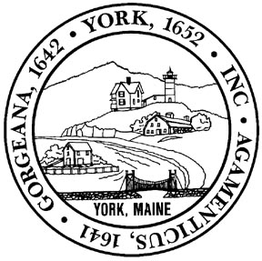
TOWN OF YORK
APPLICATION FOR MEMBERSHIP
TOWN BOARD, COMMITTEES AND COMMISSIONS
| PLEASE FILL OUT AND RETURN TO THE TOWN MANAGER’S OFFICE |
Name: ___________________________________________________________________________________
Physical Address: _________________________________________________________________________
Mailing Address: __________________________________________________________________________
Home Telephone: ___________________________ Mobile Telephone: _____________________________
Email: _______________________________________________ State of Residency: ___________________
Why do you wish to serve? _________________________________________________________________
__________________________________________________________________________________________
__________________________________________________________________________________________
__________________________________________________________________________________________
__________________________________________________________________________________________________________________________________________________________________________________________________________________________________________________________________________________________________________________________________________________________________________________________________________________________________________________________________
__________________________________________________________________________________________

What expertise can you provide? ____________________________________________________________
__________________________________________________________________________________________________________________________________________________________________________________________________________________________________________________________________________________________________________________________________________________________________________________________________________________________________________________________________________________________________________________________________________________________________________________________________________________________________________________________________________________________________________________________________________________________________________________________________________________________________________
__________________________________________________________________________________________

PLEASE CHECK THE BOARD(S), COMMITTEE(S) OR COMMISSION(S) YOU WISH TO APPLY TO FOR MEMBERSHIP CONSIDERATION:

Appeals Board | ☐ |  | Parks and Recreation Board | ☐
Assessment Review Board | ☐ |  | Planning Board | ☐
Bicycle and Pedestrian Committee | ☐ |  | Recycling Committee | ☐
Climate Action Committee | ☐ |  | Senior Citizens Advisory Board | ☐
Committee for Veterans’ Affairs | ☐ |  | Shellfish Conservation Commission | ☐
Committee to Combat Racism and Bias | ☐ |  | Sohier Park - Nubble Lighthouse | ☐
Community Center Building Committee | ☐ |  | York Community Garden Advisory | ☐
Conservation Commission | ☐ |  | York Housing Authority | ☐
Harbor Board | ☐ |  | York River Partnership Wild and Scenic | ☐
Historic District Commission | ☐ |  | Other: | ☐
Historic Markers Committee | ☐
Municipal Social Services Review Board | ☐

_____________________ BELOW IS FOR OFFICE USE ONLY_____________________

Received Date: _____/_____/________ Received By: _________________________
Interview Date: _____/_____/________ Appointment Date: _____/_____/________

