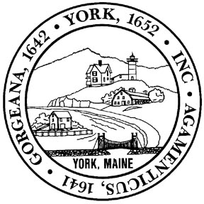

REQUEST FOR ACTION BY SELECTBOARD
DATE SUBMITTED: October 28, 2022 | ☐ DISCUSSION  ☐ ACTION  ☐ APPROVED  ☐ APPROVED W/ CHANGES  ☐ DENIED  ☐ NO ACTION TAKEN  VOTE: _______________________
DATE ACTION REQUESTED: November 14, 2022
SUBJECT: Click here to enter text.

DISCUSSION OF OPTIONS AVAILABLE TO THE BOARD: Click here to enter text.

RECOMMENDATION:
PROPOSED MOTION:

FISCAL IMPACT:
DEPARTMENT LINE ITEM ACCOUNT:
BALANCE IN LINE ITEM IF APPROVED:

PREPARED BY: ____________________________ REVIEWED BY: ____________________________

